Diplom 24 Maj 2021. Britt & Claus 2 x 400

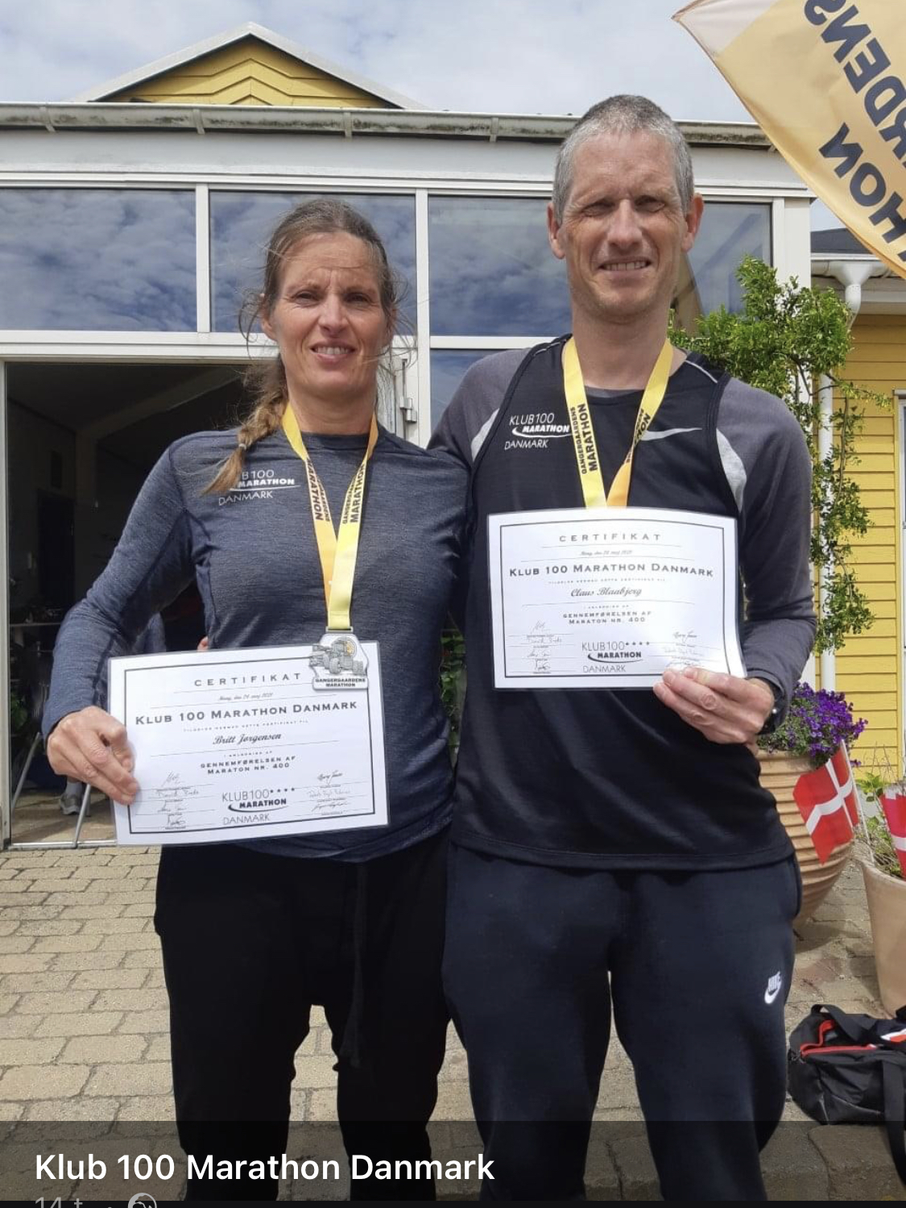

1. Luise Gangergaard - 4:18:51
2. Claus Blaabjerg # 400 # - 3:59:44
3. Britt Jørgensen # 400 # - 4:18:51
4. Hans Christian Jensen - 4:24:41
5. Harry Cilleborg - 4:18:51
6. Ole Caffel - 3:59:44
7. Lars Jensen - 5:36:33
8.Brian Jørgensen - 3:33:13
9. Brian Vernersen - 4:37:20
10. Sisse Weinreich - 5:36:38
11. Christian Thestrup - 3:59:44
12. Kirsten Bonde - 5:16:45
13. Jari Hiltune - 4:13:01
14. David Bredo - 4:00:24
15. Bo Johansen - 4:21:45
16. Betina Sørensen - 3:42:55
17. Lasse Kirkelykke - 4:15:37
18. Lise Friis - 4:18:51
19. Maja Klausen - 4:18:51
20. Kenneth Sommer - 4:03:19
21. Christian Langballe - 4:37:20
22. Claus Balshøj - 4:43:37
23. Annette Eriksen - 4:13:01
24. Søren Nielsen - 4:39:28
25. Kitt Krogh - DNF
26. Jesper Ølsgaard - 4:52:59
27. Rikke Olsen - 4:52:59
28. Jens Mogensen - 4:00:24
29. Morten Harboe-Jepsen - 4:52:59

