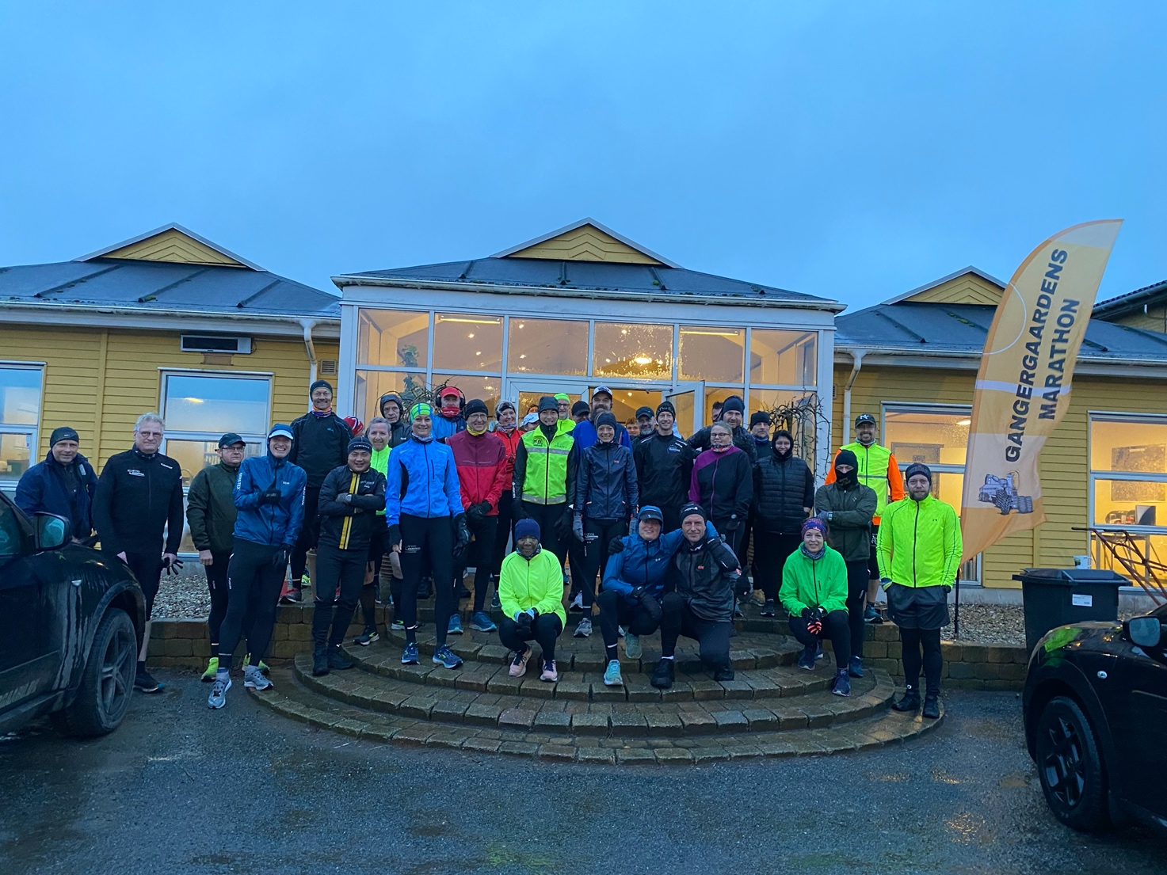
Lørdag 8 Januar 2022 ( 12 )
Marathon
1. Luise Gangergaard - 4:35:23
2. Lise Friis - 4:35:23
3. Kurt Olsen - 4:35:23
4. Harry Cilleborg - 4:35:23
5. Per Foss - 3:39:21
6. Kenneth Badensø - 4:09.48
7. Kristian H. Kjeldsen - 3:42:18
8. Carsten Toft - 4:35:26
9. Maja Florens Scheel - 4:35:23
10. Hans Christian Jensen - 4:35:23
11. Annette Eriksen - 4:35:23
12. Lasse Kirkelykke - 5:07:49
13. Morten Harboe-Jepsen - 5:15:04
14. Bo Johansen - DNS
15. Bouchra Lundgren Eriksen - 3:42:18
16. Claus Blaabjerg - 4:35:23
17. Britt Jørgensen - 4:53:47
18. Christian Thestrup - 3:52:28
19. Thomas Eul - 5:12:20
20. Jesper Saksun - DNF
21. Peter Grøn - 4:39:37
22. Kenneth Sommer - 3:30:07
23. Brian Jørgensen B1 - 3:39:25
24. Susanne Wildt - 4:55:46
25. Jari Hiltunen - DNS
26. Rikke Cebula - 4:55:56
27. Lars Jacobsen - 4:27:23
28. Erik Andersen - 4:31:31
29. Ole Toft - 4:16:31
30. Sten Ejlersen - 4:51:20
31. Pia Mortensen - DNF
32. Carsten Brix - 4:45:39
33. Karsten Langer Eriksen - 3:33:22
34. Per Hviid - 3:42:18
35. Preben Damsgaard - 4:31:31
Halv Marathon
1. Tarina Kristensen - DNS
2. Eli Nielsen - 2:20:34
3. Ester Jensen - 2:23:06
4. Jeanette Wly - 2:23:09
5. Brian Feldborg - 1:54:18
6. Peter Svoger Jakobsen - 2:18:36
7. Sandie Naja Olesen - 2:18:36
8. Birgitte Grenaa - DNS
9. Kim Henningsen - 2:23:03
10 . Anette Fog - 2:23:06
11. Mette Fly - 2:09:13
12. Mikkel Andersen - 1:54:33
13. Morten Andersen - 1:53:46
14. Anne Jeppsson - DNF
15. Monica Christensen - 2:02:40

